Pranay Gattu
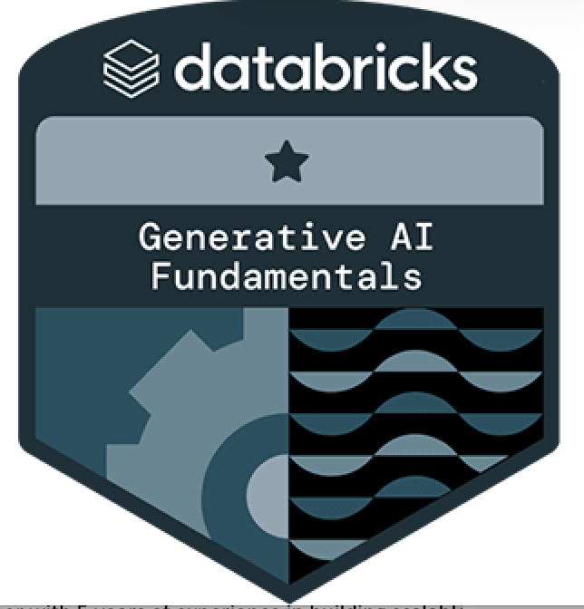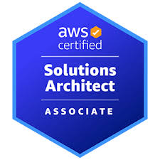
Full Stack Engineer.
762-842-9694|Pranayg2999@gmail.com|
LinkedIn
PROFESSIONAL SUMMARY

Full Stack .NET Developer with over 4 years of experience delivering scalable web and cloud solutions across healthcare, manufacturing, and fintech. Skilled in .NET Core, C#, Angular, React, SQL Server, PostgreSQL, and microservices with hands-on expertise in Azure, AWS, Docker, Kubernetes, and CI/CD pipelines. Strong in API development, security (OAuth2, JWT, Azure AD B2C, AWS Cognito), and database optimization. Certified in Azure, AWS, and Generative AI, applies SOLID principles and design patterns to consistently deliver clean, maintainable software.
TECHNICAL SKILLS

• Frontend Technologies: Angular, React, Vue.js, Blazor, TypeScript, JavaScript, HTML5, CSS3, Bootstrap, Material UI, jQuery, Ajax.
• Backend Technologies: ASP.NET Core, ASP.NET MVC, Web API, Node.js, Microservices, SignalR, gRPC.
• Programming Languages: C#, F#, VB.NET, Java, JavaScript, TypeScript, Python.
• Database & ORM: SQL Server, PostgreSQL, Oracle, MySQL, MongoDB, Entity Framework, Dapper.
• Authentication & Security: OAuth 2.0, OpenID Connect, JWT, Azure Active Directory, Identity Server.
• Testing: Unit Testing, UI & Integration Testing.
• Cloud & DevOps: Microsoft Azure, AWS, Docker, Kubernetes, Terraform, CI/CD, Azure DevOps, Jenkins, Prometheus,
• AI & Data: Azure OpenAI Service, Datbricks Lakehouse AI, RAG, Embeddings, Prompt Engineering.
• Development Tools & IDEs: Visual Studio, Visual Studio Code, SQL Server Management Studio (SSMS), Postman,
Swagger, Fiddler, Git, Azure Boards, Jira.
PROFESSIONAL EXPERIENCE

CVS Health, Phoenix, Arizona, USA. May 2023 - Present
Full Stack .NET Developer

Project Title: Healthcare Claims Management System
Responsibilities:
• Built and scaled .NET Core microservices and REST APIs to securely process claims data, ensuring proper handling of
PHI.
• Automated claims adjudication workflows, cutting manual effort by 40% while improving accuracy and HIPAA.
• Developed a responsive Angular web application with TypeScript, Bootstrap, and Material UI, improving usability for
customers and claims processors.
• Optimized SQL Server and PostgreSQL databases with stored procedures and indexing, enabling high-volume claim
transactions.
• Strengthened security with OAuth2, JWT,AWS Cognito, and RBAC, enforcing fine-grained access control and
safeguarding sensitive healthcare data.
• Automated CI/CD pipelines using GitHub Actions and Jenkins, deploying containerized applications via Docker and Kubernetes (Amazon EKS).
• Monitored application health and logs using AWS CloudWatch, ensuring high availability and production stability.
• Conducted performance tuning, troubleshooting, and code reviews to ensure system reliability, clean code practices,
and high-quality releases.

Value Labs, Hyderabad, India. April 2021 – July 2022
Application Development Associate -FullStack.NET

Project Title: United State Steel
Responsibilities:
• Contributed to a digital modernization program at U.S. Steel, migrating legacy systems into cloud-native .NET Core
applications on AWS.
• Built and maintained REST APIs and microservices to automate manufacturing and supply chain workflows, reducing
manual processes by 30%.
• Developed a responsive React frontend integrated with backend APIs, improving operator efficiency across production
sites.
• Optimized SQL Server and PostgreSQL performance using stored procedures, indexing, and ORM tools.
• Secured applications with OAuth2, JWT, MFA, and AWS Cognito, strengthening authentication and access management.
• Designed CI/CD pipelines with AWS Code Pipeline, GitHub Actions, and Jenkins, accelerating deployments and
improving release quality.
• Containerized and deployed services with Docker and Amazon EKS (Kubernetes), monitored via AWS CloudWatch for
reliability.

Flair Agile Technologies, Hyderabad, India. May 2020 - March 2021
Program Analyst

Project Title: Fraud Detection and Risk Assessment System
Responsibilities:
•Designed and developed a fraud detection and risk assessment system using .NET microservices and SQL Server,
improving detection accuracy.
• Integrated custom algorithms and third-party APIs to deliver real-time fraud scoring and analytics enhancing decision-
making speed and accuracy.
• Built a multi-tier architecture (C#.NET, SQL Server, MongoDB) to enhance scalability and performance.
• Implemented secure API access with Azure AD B2C, OAuth2, and JWT, ensuring enterprise compliance.
• Automated deployments with Azure DevOps pipelines and improved reliability through unit and integration testing.
• Contributed to UI components with WPF and backend services with WCF, strengthening system integration and user
interface consistency.
CERTIFICATIONS

• Microsoft Certified: Azure Developer – Associate – Microsoft AZ-204.
• AWS Certified Solutions Architect – Associate – Amazon Web Services (AWS).
• Generative AI Fundamentals – Databricks.
EDUCATION

• Master’s in information technology and management, University of North Texas, Texas, USA.
• BTech in Information Technology, Vardhaman College of Engineer, Hyderabad, India.

